Visit Wise County Retractable Banners are available for check-out for tourism and marketing purposes from the Wise County Office of Marketing and Community Development. Banners and associated accessory parts may be loaned to community partners, including restaurants, shops, visitor centers, special event organizers, etc., for the purpose of displaying in a public setting to promote the Visit Wise County brand.
----------------------------------------------------------------------------------------------------
Damage to Equipment. ‌ Visit Wise County Retractable Banners are the property of the County of Wise, Virginia. Loanees of the banners and associated accessory parts shall exercise all necessary precautions to avoid causing damage to the equipment. Loanees hereby assume all risk of loss, theft, damage, or destruction, partial or complete, of the equipment from any and every cause whatsoever commencing with delivery of the equipment to loanee. Loanee agrees to pay for the costs associated with repairing or replacing lost, stolen, or damaged equipment.

Loanee:

______________________________ ___________________________________________________
Organization/Event Print Name & Signature of Authorized Agent

______________________________ ___________________________________________________
Check-Out Date To Be Returned Date
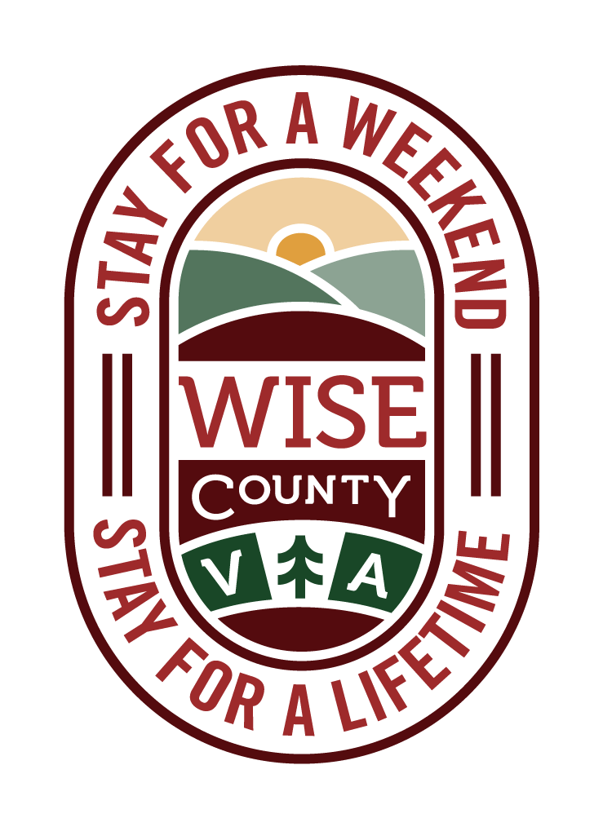

Wise County, VA:

___________________________________________________
Print Name & Signature of Authorized Agent

